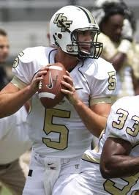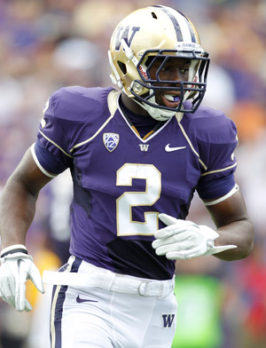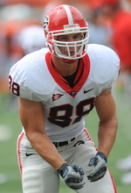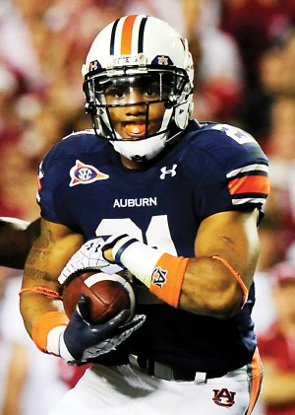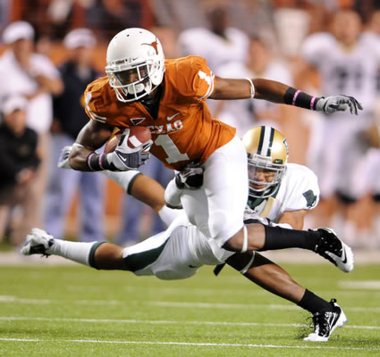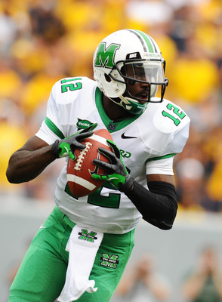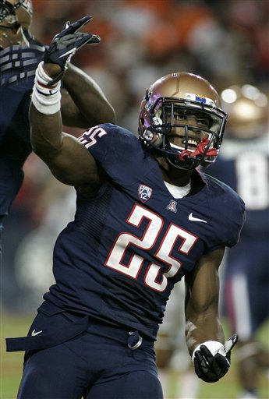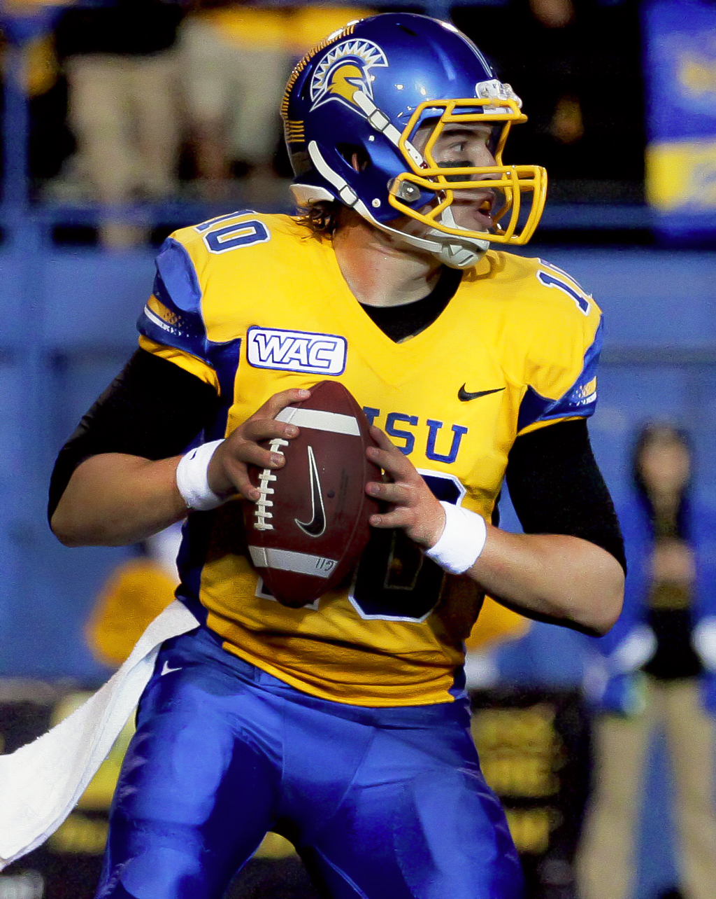

**690 players ranked!!**

CSPorts’ Top Players for the 2013 Season

# TRE MASON

# ARTHUR LYNCH

# KASEN WILLIAMS

# BLAKE BORTLES

Southern Cal, 6’0, 195, JR

Vanderbilt, 6’3, 205, SR

Clemson, 6’1, 205, JR

BYU, 6’4, 215, SR

Texas A&M, 6’5, 225, SO

Alabama, 6’1, 202, SO

Okla. State, 5’10, 185, JR

Washington, 6’2, 216, JR

Baylor, 5’10, 170, SR

Maryland, 6’1, 185, SO

Arizona, 6’3, 210, JR

Louisville, 6’3, 205, JR

Wisconsin, 6’2, 188, SR

Texas Tech, 6’0, 204, SR

Texas, 6’2, 193, SR

Georgia, 6’1, 190, JR

Oregon State, 5’10, 181, JR

Nebraska, 6’1, 185, JR

Notre Dame, 5’11, 190, SR

Mississippi, 6’3, 216, JR

**1. Marqise Lee**

**2. Jordan Matthews**

**3. Sammy Watkins**

**4. Cody Hoffman**

**5. Mike Evans**

**6. Amari Cooper**

**7. Josh Stewart**

**8. Kasen Williams**

**9. Tevin Reese**

**10. Stefon Diggs**

**11. Austin Hill**

**12. DeVante Parker**

**13. Jared Abbrederis**

**14. Eric Ward**

**15. Mike Davis**

**16. Malcolm Mitchell**

**17. Brandin Cooks**

**18. Kenny Bell**

**19. TJ Jones**

**20. Donte Moncrief**

**24. Dri Archer**

**25. Tre Mason**

**26. James Sims**

**27. LaDarius Perkins**

**28. John Hubert**

**29. Joe Bergeron**

**30. Antonio Andrews**

**31. Trey Watts**

**32. Malcolm Brown**

**33. Fitz Touissaint**

**34. Matt Jones**

**35. Jeff Scott**

**36. Storm Woods**

**37. Waymon James**

**38. Adam Mueama**

**39. Lyle McCombs**

**40. Andrew Buie**

**41. Savon Huggins**

**42. Kenny Hilliard**

**43. Marlin Lane**

**44. Kevin Parks**

**45. Trey Williams**

**46. Senorise Perry**

**47. Jerome Smith**

**48. Devonta Freeman**

**49. Alfred Blue**

**50. Beau Blankenship**

**51. Rajion Neal**

**52. Glasco Martin**

**53. Stephen Houston**

**54. David Fluellen**

**55. Kenneth Dixon**

**56. Mike Davis**

**57. Marion Grice**

**58. Dominique Brown**

**59. David Sims**

**60. Zack Zwinak**

**61. Byron Marshall**

**62. David Oku**

Kent State, 5’8, 175, SR

Auburn, 5’10, 196, JR

Kansas, 6’0, 202, SR

Miss. State, 5’10, 190, SR

Kansas State, 5’7, 191, SR

Texas, 6’1, 240, JR

W. Kentucky, 6’0, 211, SR

Tulsa, 5’11, 190, SR

Texas, 6’0, 223, JR

Michigan, 5’10, 200, SR

Florida, 6’2, 226, SO

Mississippi, 5’7, 170, SR

Oregon State, 6’0, 197, SO

TCU, 5’8, 208, SR

San Diego St, 5’10, 205, JR

Connecticut, 5’8, 169, JR

West Virginia, 5’9, 187, JR

Rutgers, 6’0, 200, JR

LSU, 6’0, 231, JR

Tennessee, 5’11, 205, JR

Virginia, 5’8, 200, JR

Texas A&M, 5’8, 185, SO

Louisville, 6’0, 203, SR

Syracuse, 5’11, 213, SR

Florida State, 5’9, 209, JR

LSU, 6’2, 220, SR

Ohio, 5’8, 202, SR

Tennessee, 5’11, 211, SR

Baylor, 6’1, 220, SR

Indiana, 6’0, 225, SR

Toledo, 6’0, 215, SR

Louisiana Tech, 6’0, 215, SO

South Carolina, 5’9, 215, SO

Arizona State, 6’0, 204, SO

Louisville, 6’2, 230, JR

Georgia Tech, 6’0, 222, SR

Penn State, 6’1, 234, SR

Oregon, 5’10, 201, SO

Arkansas State, 5’10, 195, SR

# TOP RUNNING BACKS

**1. Todd Gurley**

**2. TJ Yeldon**

**3. Duke Johnson**

**4. Ka’Deem Carey**

**5. Lache Seastrunk**

**6. De’Anthony Thomas**

**7. James White**

**8. Damien Williams**

**9. James Wilder, Jr.**

**10. Keith Marshall**

**11. Charles Sims**

**12. Johnathan Gray**

**13. Jeremy Hill**

**14. Silas Redd**

**15. Melvin Gordon**

**16. Venric Mark**

**17. Ameer Abdullah**

**18. Jeremy Smith**

**19. Carlos Hyde**

**20. Storm Johnson**

**21. Ben Malena**

**22. Bishop Sankey**

Georgia, 6’1, 232, SO

Alabama, 6’2, 218, SO

Miami, 5’9, 194, SO

Arizona, 5’10, 196, JR

Baylor, 5’10, 210, JR

Oregon, 5’9, 176, JR

Wisconsin, 5’10, 197, SR

Oklahoma, 5’11, 214, SR

Florida State, 6’2, 226, JR

Georgia, 5’11, 219, SO

Houston, 6’0, 215, SR

Texas, 5’11, 207, SO

LSU, 6’2, 235, SO

Southern Cal, 5’10, 200, SR

Wisconsin, 6’1, 203, SO

Northwestern, 5’8, 175, SR

Nebraska, 5’9, 190, JR

Okla. State, 5’10, 208, SR

Ohio State, 6’0, 242, SR

UCF, 6’1, 217, JR

Texas A&M, 5’8, 195, SR

Washington, 5’10, 200, JR

# TOP QUARTERBACKS

Louisville, 6’1, 218, JR

Georgia, 6’1, 208, SR

Texas A&M, 6’1, 200, SO

Clemson, 6’1, 225, SR

Alabama, 6’4, 214, SR

Ohio State, 6’2, 215, JR

Oregon, 6’4, 211, SO

San Jose State, 6’3, 220, SR

Fresno State, 6’3, 210, SR

North Carolina, 6’3, 225, SR

LSU, 6’5, 230, SR

Nebraska, 6’1, 210, SR

UCLA, 6’3, 227, SO

Utah State, 6’2, 200, JR

N. Illinois, 6’0, 216, SR

TCU, 6’5, 230, SR

Virginia Tech, 6’6, 257, SR

Florida, 6’4, 237, JR

Stanford, 6’4, 220, JR

UCF, 6’4, 227, JR

Texas, 6’3, 223, JR

Marshall, 6’0, 182, JR

South Carolina, 6’1, 209, SR

Arizona State, 6’2, 203, JR

Missouri, 6’2, 230, SR

Notre Dame, 6’0, 185, JR

Michigan, 6’4, 210, JR

Ohio, 6’0, 198, SR

Washington, 6’1, 202, SR

Rutgers, 6’2, 225, JR

Miami, 6’2, 214, SR

Oregon State, 6’5, 214, JR

Miss. State, 6’4, 220, SR

Louisiana, 6’2, 205, JR

Okla. State, 6’1, 210, SR

Okla. State, 6’2, 205, SO

Nevada, 6’2, 210, JR

Northwestern, 6’0, 190, SR

Toledo, 6’4, 195, SR

Oklahoma, 6’6, 263, JR

La. Monroe, 6’1, 211, SR

Mississippi, 6’4, 204, JR

West Virginia, 6’5, 234, rFR

Tulsa, 6’4, 247, SR

Wyoming, 6’3, 205, JR

Boston College, 6’3, 213, SR

Boise State, 6’1, 202, SR

Southern Cal, 6’4, 235, SO

Texas Tech, 6’1, 183, SO

Wake Forest, 6’2, 205, SR

Notre Dame, 6’2, 210, SR

Baylor, 6’3, 230, JR

Florida State, 6’4, 218, rFR

**1. Teddy Bridgewater**

**2. Aaron Murray**

**3. Johnny Manziel**

**4. Tajh Boyd**

**5. AJ McCarron**

**6. Braxton Miller**

**7. Marcus Mariota**

**8. David Fales**

**9. Derek Carr**

**10. Bryn Renner**

**11. Zach Mettenberger**

**12. Taylor Martinez**

**13. Brett Hundley**

**14. Chuckie Keeton**

**15. Jordan Lynch**

**16. Casey Pachall**

**17. Logan Thomas**

**18. Jeff Driskel**

**19. Kevin Hogan**

**20. Blake Bortles**

**21. David Ash**

**22. Rakeem Cato**

**23. Connor Shaw**

**24. Taylor Kelly**

**25. James Franklin**

**26. Everett Golson**

**27. Devin Gardner**

**28. Tyler Tettleton**

**29. Keith Price**

**30. Gary Nova**

**31. Stephen Morris**

**32. Sean Mannion**

**33. Tyler Russell**

**34. Terrance Broadway**

**35. Clint Chelf**

**36. JW Walsh**

**37. Cody Fajardo**

**38. Kain Colter**

**39. Terrance Owens**

**40. Blake Bell**

**41. Kolton Browning**

**42. Bo Wallace**

**43. Ford Childress**

**44. Cody Green**

**45. Brett Smith**

**46. Chase Rettig**

**47. Joe Southwick**

**48. Max Wittek**

**49. Michael Brewer**

**50. Tanner Price**

**51. Tommy Rees**

**52. Bryce Petty**

**53. Jameis Winston**

Penn State, 6’3, 204, JR

Fresno State, 6’2, 200, SO

Rutgers, 6’6, 220, SR

Texas, 6’1, 192, SO

Michigan, 5’8, 187, SR

Missouri, 6’6, 220, SO

Oklahoma, 5’9, 160, SR

San Jose St, 5’11, 175, SR

LSU, 6’0, 187, JR

Ohio State, 6’0, 187, SR

New Mexico St, 6’2, 180, JR

Oklahoma, 5’10, 188, SO

Boise State, 6’3, 218, JR

Louisville, 6’1, 183, SR

Miami (OH), 6’1, 193, JR

North Carolina, 6’4, 205, SR

Florida State, 6’0, 175, JR

Houston, 6’3, 198, SO

UCLA, 6’1, 211, SR

TCU, 5’11, 186, JR

West Virginia, 6’2, 183, SR

Boston Coll., 5’11, 186, SR

Tulane, 6’1, 190, SR

LSU, 6’1, 195, JR

Louisville, 5’10, 185, JR

Okla. State, 6’2, 215, SR

Georgia, 6’3, 205, JR

Ohio State, 6’1, 198, JR

California, 6’0, 16, SO

Southern Cal, 6’1, 185, SO

Notre Dame, 6’2, 190, JR

Okla. State, 6’2, 202, SR

Indiana, 6’3, 215, JR

East Carolina, 6’0, 186, JR

Miami, 5’9, 187, JR

South Florida, 6’1, 202, JR

Buffalo, 6’3, 205, SR

**1. Trey Milliard**

**2. Ryan Hewitt**

**3. Trey Burton**

**4. JC Copeland**

**5. Jay Prosch**

**6. Gator Hoskins**

**7. Hunter Joyer**

**8. Jalston Fowler**

**9. CJ Zimmerer**

Washington, 6’6, 266, JR

North Carolina, 6’4, 245, JR

Wisconsin, 6’4, 241, SR

Georgia, 6’5, 254, SR

Arizona State, 6’3, 222, SR

Southern Cal, 6’5, 255, JR

Penn State, 6’3, 240, SO

Okla. State, 6’3, 235, SR

Michigan, 6’5, 228, SO

Iowa, 6’7, 265, SR

Oregon, 6’5, 246, JR

Ball State, 6’3, 237, SR

Louisville, 6’3, 260, JR

Florida State, 6’3, 238, JR

Texas Tech, 6’5, 257, JR

Southern Cal, 6’4, 255, JR

Miami, 6’4, 259, JR

Texas A&M, 6’4, 250, SR

Baylor, 6’6, 260, SR

BYU, 6’5, 250, SR

Colorado St., 6’6, 245, SR

Virginia, 6’5, 235, JR

Indiana, 6’6, 254, SR

NC State, 6’3, 237, SR

East Carolina, 6’8, 277, SR

Boise State, 6’4, 241, SR

Nebraska, 6’4, 240, SR

South Carolina, 6’5, 242, JR

**1. Austin Seferian-Jenkins**

**2. Eric Ebron**

**3. Jacob Pedersen**

**4. Arthur Lynch**

**5. Chris Coyle**

**6. Xavier Grimble**

**7. Kyle Carter**

**8. Blake Jackson**

**9. Devin Funshess**

**10. CJ Fiedorowicz**

**11. Colt Lyerla**

**12. Zane Fakes**

**13. Gerald Christian**

**14. Nick O’Leary**

**15. Jace Amaro**

**16. Randall Telfer**

**17. Clive Walford**

**18. Nehemiah Hicks**

**19. Jordan Najvar**

**20. Kaneakua Friel**

**21. Crockett Gillmore**

**22. Jake McGee**

**23. Ted Bolser**

**24. Asa Watson**

**25. Justin Jones**

**26. Gabe Lineham**

**27. Jake Long**

**28. Rory Anderson**

**21. Allen Robinson**

**22. Davante Adams**

**23. Brandon Coleman**

**24. Jaxon Shipley**

**25. Jeremy Gallon**

**26. Dorial Green-Beckham**

**27. Jalen Saunders**

**28. Noel Grigsby**

**29. Odell Beckham, Jr.**

**30. Philly Brown**

**31. Austin Franklin**

**32. Sterling Shepard**

**33. Matt Miller**

**34. Damian Copeland**

**35. Nick Harwell**

**36. Quinshad Davis**

**37. Rashad Greene**

**38. Deontay Greenberry**

**39. Shaquelle Evans**

**40. Brandon Carter**

**41. Ivan McCartney**

**42. Alex Amidon**

**43. Ryan Grant**

**44. Jarvis Landry**

**45. Eli Rogers**

**46. Tracy Moore**

**47. Michael Bennett**

**48. Devin Smith**

**49. Chris Harper**

**50. Nelson Agholor**

**51. DaVaris Daniels**

**52. Charlie Moore**

**53. Cody Latimer**

**54. Justin Hardy**

**55. Phillip Dorsett**

**56. Andre Davis**

**57. Alex Neutz**

Oklahoma, 6’2, 259, SR

Stanford, 6’4, 245, SR

Florida, 6’3, 228, SR

LSU, 6’1, 272, SR

Auburn, 6’0, 247, SR

Marshall, 6’2, 240, SR

Florida, 5’10, 249, JR

Alabama, 6’1, 250, JR

Nebraska, 6’0 ,230, SR

# TOP RUNNING BACKS CONTINUED

# MIKE DAVIS

# RAKEEM CATO

# KA’DEEM CAREY

# DAVID FALES

# TOP TIGHT ENDS

# TOP WIDE RECEIVERS

# TOP FULLBACKS

# TOP OFFENSIVE GUARDS

**1. Oday Aboushi**

**2. Ricky Wagner**

**3. Alex Hurst**

**4. DJ Fluker**

**5. Seantrel Henderson**

**6. Jake Matthews**

**7. Luke Joeckel**

**8. Taylor Lewan**

**9. Chris Faulk**

**10. Justin Pugh**

**11. Morgan Moses**

**12. Zack Martin**

**13. James Hurst**

**14. Jason Weaver**

**15. LaAdrian Waddle**

**16. Tanner Hawkinson**

**17. David Quessenberry**

**18. Manase Foketi**

**19. Jeremiah Sirles**

**20. Xavier Nixon**

**21. Cyril Richardson**

**22. David Bakhtiari**

**23. RJ Mattes**

**24. Kevin Graf**

**25. Brennan Williams**

**26. Fou Fonoti**

**27. Ja’Wuan James**

**28. Braden Brown**

**29. Chaz Green**

**30. Dan France**

**31. Cameron Fleming**

**32. Matt Summers-Gavin**

**33. Emmett Cleary**

**34. Reid Fragel**

**35. Antonio Richardson**

**36. Jeff Braun**

**37. Michael Philipp**

**38. Jeff Nady**

**39. Trevor Foy**

**40. Erik Kohler**

**41. Elvis Fisher**

**42. Dann O’Neill**

**43. Cyrus Kouandjio**

**44. Mark Popek**

**45. Nick Cody**

**46. Bobby Hart**

**47. Brandon Scherff**

**48. Wesley Johnson**

**49. Patrick Ward**

**50. Michael Bowie**

**51. Rob Crisp**

**52. Ed Olson**

**53. Caylin Hauptmann**

**54. Sean Hooey**

**55. Nick Becton**

**56. Ryan Dannewitz**

**57. John Fullington**

**58. Casey Dehn**

**59. RJ Dill**

**60. Josh Cochran**

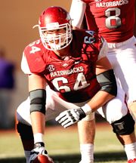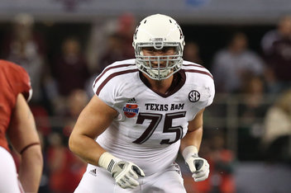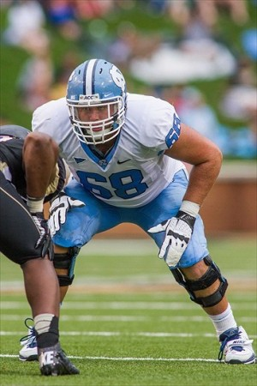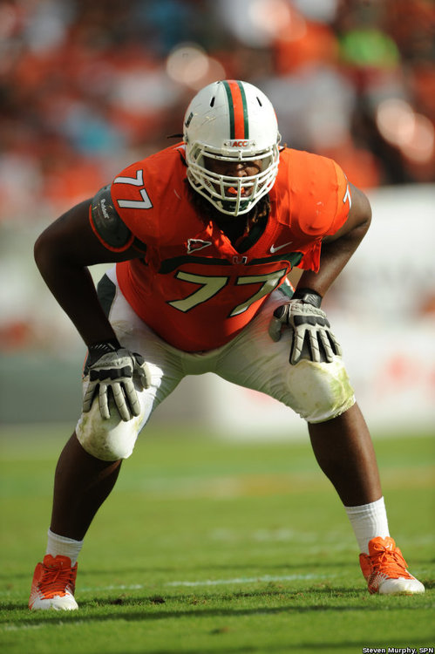

# TOP OFFENSIVE GUARDS

Stanford, 6’5, 311, SR

Baylor, 6’5, 335, SR

Miss. State, 6’4, 320, SR

Alabama, 6’3, 309, SR

Ohio State, 6’6, 319, SR

Nebraska, 6’4, 315, SR

Florida State, 6’4, 327, JR

Penn State, 6’3, 300, SR

Texas, 6’6, 320, SR

Florida State, 6’6, 326, JR

Notre Dame, 6’3, 310, SR

Oklahoma, 6’5, 315, SR

Georgia, 6’2, 314, SR

Miami, 6’6, 317, SR

Rutgers, 6’4, 301, SR

South Carolina, 6’4, 314, JR

Tennessee, 6’5, 324, SR

Texas, 6’4, 300, SR

Stanford, 6’6, 292, SR

Ohio State, 6’6, 315, SR

Cincinnati, 6’5, 285, SR

Southern Cal, 6’6, 285, SO

Utah State, 6’4, 308, SR

Florida, 6’3, 321, SR

Oklahoma, 6’4, 311, JR

Louisville, 6’4, 314, JR

Duke, 6’3, 320, JR

LSU, 6’3, 306, SO

Georgia, 6’5, 327, SR

Oregon State, 6’6, 290, SR

Miami, 6’5, 318, JR

Southern Cal, 6’2, 305, SR

Florida, 6’4, 307, JR

UCF, 6’4, 309, SR

Arkansas, 6’7, 317, JR

Michigan State, 6’3, 300, SR

NC State, 6’5, 300, SR

Alabama, 6’5, 325, JR

Louisville, 6’2, 321, JR

Utah State, 6’2, 302, SR

Virginia Tech, 6’5, 301, JR

LSU, 6’7, 332, SR

San Jose State, 6’4, 292, SR

Texas A&M, 6’4, 320, JR

Clemson, 6’3, 295, SR

Indiana, 6’2, 303, JR

Georgia Tech, 6’3, 290, SR

Washington, 6’4, 299, SR

Nebraska, 6’6, 305, JR

East Carolina, 6’5, 342, SR

Georgia, 6’4, 295, SR

Auburn, 6’5, 308, JR

**1. David Yankey**

**2. Cyril Richardson**

**3. Gabe Jackson**

**4. Anthony Steen**

**5. Andrew Norwell**

**6. Spencer Long**

**7. Tre’ Jackson**

**8. John Urschel**

**9. Mason Walters**

**10. Josue Matias**

**11. Chris Watt**

**12. Bronson Irwin**

**13. Chris Burnette**

**14. Brandon Liner**

**16. Antwan Lowery**

**17. AJ Cann**

**18. Zach Fulton**

**19. Trey Hopkins**

**20. Kevin Danser**

**21. Marcus Hall**

**22. Austen Bujnoch**

**23. Max Tuerk**

**24. Eric Schultz**

**25. Jon Halapio**

**26. Adam Shead**

**27. Jake Smith**

**28. Laken Tomlinson**

**29. Trai Turner**

**30. Kenarious Gates**

**31. Grant Enger**

**32. Jon Feliciano**

**33. John Martinez**

**34. Max Garcia**

**35. Jordan McCray**

**36. Brey Cook**

**37. Blake Treadwell**

**38. Duran Christophe**

**39. Arie Kouandjio**

**40. John Miller**

**41. Jamie Markosian**

**42. Brent Benedict**

**43. Josh Willford**

**44. Nicholas Kaspar**

**45. Jarvis Harrison**

**46. Tyler Shatley**

**47. Bernard Taylor**

**48. Will Jackson**

**49. Erik Kohler**

**50. Jake Cotton**

**51. Will Simmons**

**52. Dallas Lee**

**53. Chad Slade**

# TOP OFFENSIVE TACKLES

**1. Jake Matthews**

**2. Taylor Lewan**

**3. James Hurst**

**4. Antonio Richardson**

**5. Zack Martin**

**6. Xavier Su’a Filo**

**7. Ja’Wuan James**

**8. Cyrus Kouandjio**

**9. Brandon Thomas**

**10. Cameron Fleming**

**11. Morgan Moses**

**12. Cornelius Lucas**

**13. Seantrel Henderson**

**14. Le’Raven Clark**

**15. Jeremiah Sirles**

**16. La’El Collins**

**17. Cedric Ogbuehi**

**18. Jack Mewhort**

**19. Christian Lombard**

**20. Cameron Erving**

**21. Brandon Scherff**

**22. Tyler Johnstone**

**23. Evan Finkenberg**

**24. Kaleb Johnson**

**25. Spencer Drango**

**26. Kevin Graf**

**27. Jake Fisher**

**28. Vadal Alexander**

**29. Jamon Brown**

**30. Quinton Spain**

**31. Rob Havenstein**

**32. Wesley Johnson**

**33. Ryan Groy**

**34. Michael Philipp**

**35. Fou Fonoti**

**36. Josh Cochran**

**37. Aundrey Walker**

**38. Donald Hawkins**

**39. Dan France**

**40. Austin Wentworth**

**41. Skyler Burkland**

**42. Eric Lefeld**

**43. John Fullington**

**44. Ryker Mathews**

**45. John Theus**

**46. Ed Olson**

**47. Torrian Wilson**

**48. Tayo Fabuluje**

**49. Gregory Robinson**

**50. Rob Crisp**

**51. Michael Schofield**

**52. Chaz Green**

**53. DJ Humphries**

**54. Quinterrius Eatmon**

**55. Brandon Shell**

**56. Trevor Foy**

**57. Percy Taumoelau**

**58. Emmanuel McCray**

Texas A&M, 6’5, 305, SR

Michigan, 6’8, 308, SR

North Carolina, 6’7, 305, SR

Tennessee, 6’6, 332, JR

Notre Dame, 6’4, 304, SR

UCLA, 6’3, 304, JR

Tennessee, 6’6, 323, SR

Alabama, 6’6, 310, JR

Clemson, 6’3, 305, SR

Stanford, 6’6, 318, SR

Virginia, 6’6, 325, SR

Kansas State, 6’9, 328, SR

Miami, 6’8, 325, SR

Texas Tech, 6’5, 303, SO

Nebraska, 6’6, 310, SR

LSU, 6’5, 321, JR

Texas A&M, 6’5, 300, JR

Ohio State, 6’7, 308, SR

Notre Dame, 6’5, 309, SR

Florida State, 6’6, 310, JR

Iowa, 6’5, 310, JR

Oregon, 6’6, 292, SO

Arizona State, 6’4, 293, SR

Rutgers, 6’4, 300, JR

Baylor, 6’6, 315, SO

Southern Cal, 6’6, 300, SR

Oregon, 6’6, 294, JR

LSU, 6’6, 350, SO

Louisville, 6’6, 337, JR

West Virginia, 6’5, 335, JR

Wisconsin, 6’8, 338, JR

Vanderbilt, 6’5, 285, SR

Wisconsin, 6’5, 317, SR

Oregon State, 6’4, 329, SR

Michigan State, 6’4, 298, SR

Texas, 6’6, 299, JR

Southern Cal, 6’6, 300, JR

Texas, 6’5, 310, SR

Michigan State, 6’6, 315, SR

Fresno State, 6’5, 299, SR

Michigan State, 6’7, 315, JR

Cincinnati, 6’6, 287, JR

Wash. State, 6’5, 290, SR

BYU, 6’6, 292, SO

Georgia, 6’6, 298, SO

Minnesota, 6’7, 309, SR

UCF, 6’4, 308, JR

TCU, 6’7, 315, JR

Auburn, 6’5, 305, SO

NC State, 6’7, 298, SR

Michigan, 6’7, 303, SR

Florida, 6’5, 310, JR

Florida, 6’5, 280, SO

South Florida, 6’6, 311, JR

South Carolina, 6’6, 323, SO

Purdue, 6’7, 300, SR

Utah, 6’4, 310, SR

Mississippi, 6’5, 316, SR

# JAKE MATTHEWS

# JAMES HURST

# SEANTREL HENDERSON

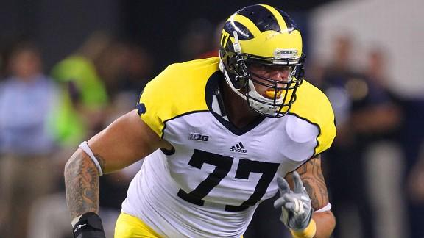

# TAYLOR LEWAN

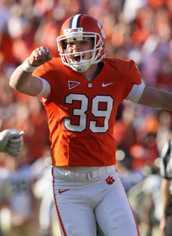

# TOP CENTERS

Ohio State, 6’3, 297, SR

Colorado State, 6’4, 297, SR

Missouri, 6’3, 315, SO

Texas, 6’4, 300, JR

Mississippi, 6’4, 295, SR

Louisville, 6’3, 270, SR

BYU, 6’2, 205, SR

Syracuse, 6’2, 280, SR

Michigan State, 6’3, 280, JR

New Mexico, 6’5, 292, SR

Georgia, 6’2, 295, JR

Alabama, 6’5, 290, SO

Arizona State, 6’3, 290, SR

Colorado, 6’3, 290, SR

W. Kentucky, 6’3, 305, SR

South Florida, 6’3, 275, JR

Idaho, 6’2, 296, JR

**19. Corey Linsley**

**20. Weston Richburg**

**21. Evan Boehm**

**22. Dominic Espinosa**

**23. Evan Swindall**

**24. Kamran Joyer**

**25. Houston Reynolds**

**26. Macky MacPherson**

**27. Travis Jackson**

**28. Dillon Farrell**

**29. David Andrews**

**30. Ryan Kelly**

**31. Kody Koebensky**

**32. Gus Handler**

**33. Sean Conway**

**34. Austin Reiter**

**34. Mike Marboe**

Arkansas, 6’5, 305, SR

Oklahoma, 6’3, 298, SR

Florida State, 6’4, 312, SR

Oregon, 6’3, 294, JR

Kansas State, 6’4, 303, JR

North Carolina, 6’4, 310, JR

Utah State, 6’4, 312, SR

Tennessee, 6’3, 300, SR

Toledo, 6’5, 300, SR

UCLA, 6’4, 276, SO

Georgia Tech, 6’3, 285, SR

Auburn, 6’3, 290, JR

Miss. State, 6’4, 300, JR

Miami, 6’4, 296, JR

Florida, 6’4, 299, SR

Oregon State, 6’3, 300, SO

Northwestern, 6’3, 300, JR

**1. Travis Swanson**

**2. Gabe Ikard**

**3. Bryan Stork**

**4. Hroniss Grasu**

**5. BJ Finney**

**6. Russell Bodine**

**7. Tyler Larsen**

**8. James Stone**

**9. Zac Kerin**

**10. Jake Brendel**

**11. Jay Finch**

**12. Reese Dismukes**

**13. Dillon Day**

**14. Shane McDermott**

**15. Jonotthan Harrison**

**16. Isaac Seumalo**

**17. Brandon Vitabile**

# CHANDLER CATANZARO

# TRAVIS SWANSON

Rice, 6’2, 200, SR

Tulane, 5’8, 160, SR

Clemson, 6’2, 195, SR

Arkansas, 6’0, 180, SR

Syracuse, 5’7, 157, SR

Northwestern, 5’11, 165, SR

Baylor, 6’3, 190, SR

Oklahoma, 6’1, 169, JR

Southern Cal, 5’10, 200, JR

UAB, 6’2, 188, JR

Iowa, 6’2, 185, SR

Vanderbilt, 5’10, 190, SR

Stanford, 5’11, 191, SR

Texas A&M, 5’9, 174, SO

California, 6’1, 200, SR

Boston College, 6’0, 185, SR

Ohio State, 6’2, 210, SR

# TOP KICKERS

**1. Chris Boswell**

**2. Cairo Santos**

**3. Chandler Catanzaro**

**4. Zach Hocker**

**5. Ross Krautman**

**6. Jeff Budzien**

**7. Aaron Jones**

**8. Michael Hunnicutt**

**9. Andre Heidari**

**10. Ty Long**

**11. Mike Meyer**

**12. Casey Spear**

**13. Jordan Williamson**

**14. Taylor Bertolet**

**15. Vincenzo D’Amato**

**16. Nate Freese**

**17. Drew Basil**

**F**

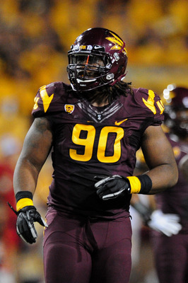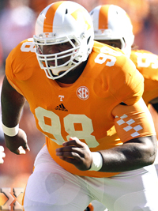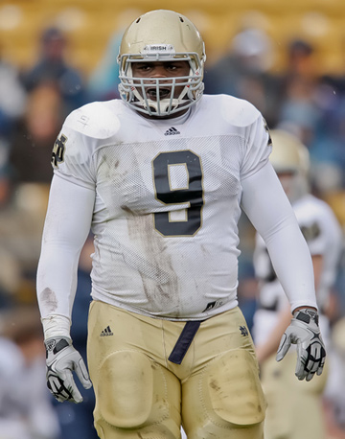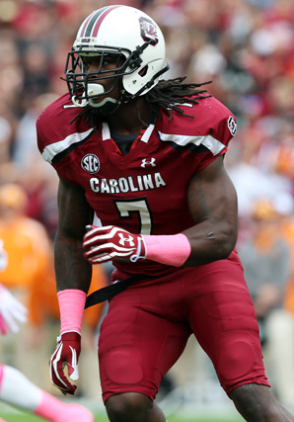 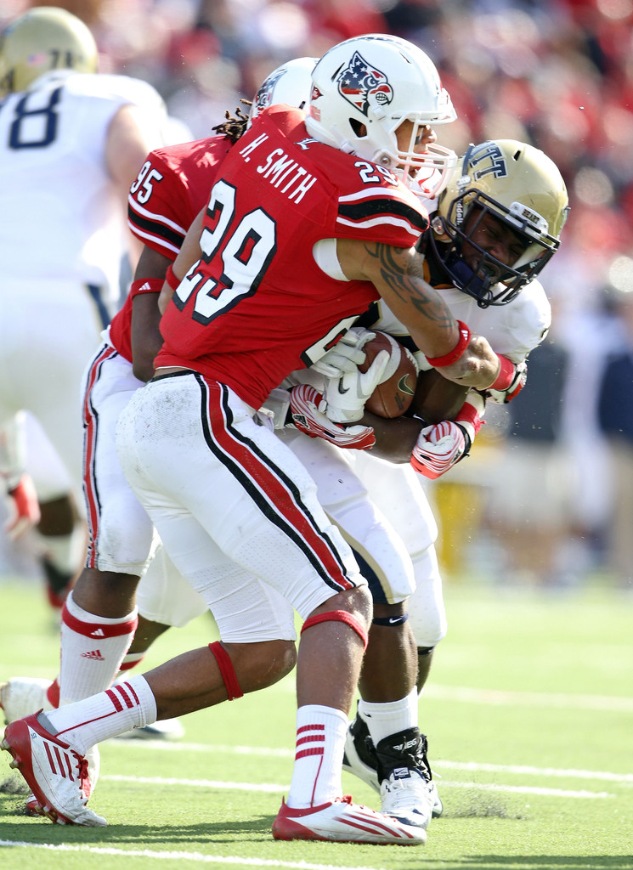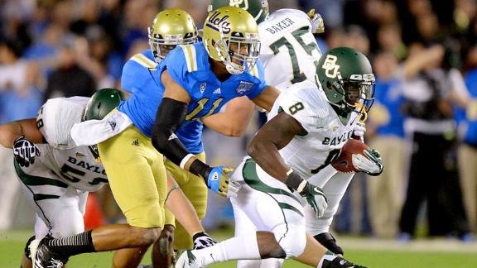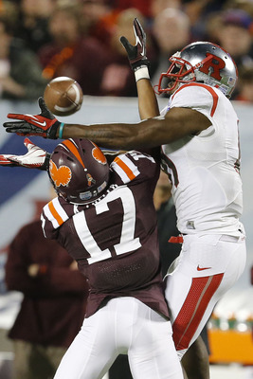 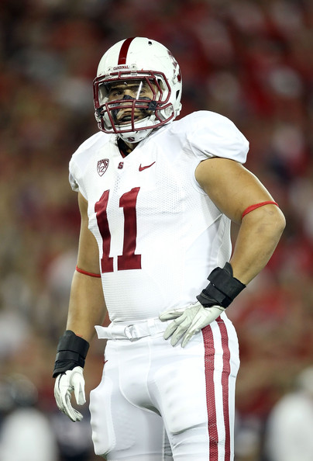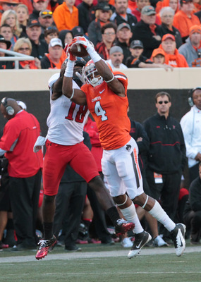

Florida, 6’3, 193, JR

Duke, 6’4, 210, SO

Houston, 6’3, 215, SR

Iowa State, 6’4, 211, SR

Michigan State, 6’0, 185, SO

TCU, 6’4, 230, SO

Cincinnati, 6’5, 222, SR

Purdue, 6’1, 210, SR

Auburn, 6’5, 232, SR

Bowling Green, 6’3, 226, SR

Colorado, 6’2, 185, JR

Alabama, 6’4, 213, SR

North Carolina, 5’10, 190, JR

Memphis, 6’3, 195, SR

Michigan, 6’4, 227, SR

South Carolina, 6’6, 274, JR

Notre Dame, 6’6, 303, JR

Texas, 6’5, 245, SR

Stanford, 6’4, 275, SR

Virginia Tech, 6’4, 253, SR

TCU, 6’4, 240, SO

South Florida, 6’6, 244, SO

Oregon State, 6’3, 260, JR

Arkansas, 6’3, 266, SR

Boise State, 6’3, 244, JR

Southern Cal, 6’2, 250, SR

Stanford, 6’6, 282, SR

Penn State, 6’4, 244, SO

Georgia Tech, 6’3, 240, SR

Alabama, 6’4, 292, SR

North Carolina, 6’6, 265, SR

Arkansas, 6’4, 256, JR

Miami, 6’4, 269, JR

Texas Tech, 6’2, 281, SR

Florida, 6’3, 277, SO

Clemson, 6’3, 225, JR

Miss. State, 6’5, 255, JR

Oregon, 6’6, 292, SR

Florida State, 6’3, 282, SO

UCLA, 6’4, 268, SR

Northwestern, 6’4, 265, SR

Alabama, 6’4, 290, JR

Ohio State, 6’3, 247, SO

Louisville, 6’3, 256, SR

Memphis, 6’3, 260, JR

Mississippi, 6’3, 233, JR

Virginia Tech, 6’2, 252, SR

UCLA, 6’3, 265, SR

Michigan State, 6’2, 250, JR

Missouri, 6’5, 275, JR

Louisville, 6’4, 240, JR

Rutgers, 6’4, 255, SR

South Florida, 6’3, 253, SR

Auburn, 6’2, 238, SR

West Virginia, 6’7, 273, SR

Ohio State, 6’3, 292, SO

North Carolina, 6’5, 270, SR

Florida, 6’4, 244, JR

Virginia Tech, 6’1, 225, SR

Nevada, 6’4, 255, JR

Kentucky, 6’4, 254, JR

Texas, 6’6, 250, JR

Georgia Tech, 6’4, 300, SR

Washington, 6’3, 230, JR

Utah, 6’5, 245, SR

UTEP, 6’1, 240, SR

South Carolina, 6’5, 263, JR

NC State, 6’3, 266, SR

Michigan, 6’2, 277, JR

LSU, 6’3, 255, JR

Georgia, 6’3, 299, SR

Louisiana, 6’1, 285, JR

Florida State, 6’6, 273, SO

Virginia, 6’4, 255, SO

Duke, 6’3, 245, SR

Vanderbilt, 6’5, 250, SR

Louisiana Tech, 6’2, 250, SR

Louisville,

**1. Jadeveon Clowney**

**2. Stephon Tuitt**

**3. Jackson Jeffcoat**

**4. Ben Gardner**

**5. James Gayle**

**6. Devonte Fields**

**7. Aaron Lynch**

**8. Scott Crichton**

**9. Chris Smith**

**10. Demarcus Lawrence**

**11. Morgan Breslin**

**12. Henry Anderson**

**13. Deion Barnes**

**14. Jeremiah Attaochu**

**15. Ed Stinson**

**16. Kareem Martin**

**17. Trey Flowers**

**18. Anthony Chickillo**

**19. Kerry Hyder**

**20. Dante Fowler, Jr.**

**21. Vic Beasley**

**22. Denico Autry**

**23. Taylor Hart**

**24. Mario Edwards**

**25. Cassius Marsh**

**26. Tyler Scott**

**27. Jeoffrey Pagan**

**28. Noah Spence**

**29. Marcus Smith**

**30. Martin Ifedi**

**31. CJ Johnson**

**32. JR Collins**

**33. Owamagbe Odighizuwa**

**34. Marcus Rush**

**35. Kony Ealy**

**36. Lorenzo Mauldin**

**37. Jamil Merrell**

**38. Ryne Giddins**

**39. Dee Ford**

**40. Will Clarke**

**41. Adolphus Washington**

**42. Tim Jackson**

**43. Ronald Powell**

**44. Tyrel Wilson**

**45. Brock Hekking**

**46. Alvin Dupree**

**47. Cedric Reed**

**48. Izaan Cross**

**49. Josh Shirley**

**50. Trevor Reilly**

**51. Horace Miller**

**52. Chaz Sutton**

**53. Darryl Cato-Bishop**

**54. Frank Clark**

**55. Jermauria Rasco**

**56. Garrison Smith**

**57. Christian Ringo**

**58. Giorgio Newberry**

**59. Eli Harold**

**60. Justin Foxx**

**61. Walker May**

**I rank as many players nationwide as I can. I rank each player on their skills at their position. I do not rank players based ENTIRELY on stats, (that does not mean that stats are not a factor in ranking the players above) that is unfair to that player and the other players being ranked. If a player threw for 5,000 plus yards a season ago and is not found in the top five quarterbacks for this season do not be surprised, but some players in the top five may have had very productive numbers and are more deserving of that ranking than others. I wanted to get this across before I get questions about why isn’t this player ranked ahead of this player when this player threw for 350 more yards.**

**Even though a player may be ranked in the top four or so of their given position, that does not necessarily mean that that player will be on one of my four All-American teams. Most All-American teams (mine included) are based mostly on stats and the production of a player from week one to the final game. That doesn’t mean someone who throws for 5,000 yards is going to be first team All-America but they may have a better shot at being on the team as opposed to a better quarterback who barely passed for 2,000 yards.**

*Player rankings are completed on May 10th. So, if a player was injured or had left the team after May 10th he may still be listed.

*I do **not** rank true freshmen and rarely will you see a redshirt freshman listed on my player rankings.

* I **do** rank players that were injured in the spring that could possibly not play in the fall. So, some of the players listed may not be in uniform for the majority of the season.

*Many players are subject to change positions from the period of spring to summer. (Most commonly in offensive lineman and defensive backs)

# LOUIS NIX III

# WILL SUTTON

# DANIEL MCCULLERS

# JADEVEON CLOWNEY

LSU, 6’3, 304, JR

Arizona State, 6’1, 288, SR

Notre Dame, 6’3, 326, SR

Pittsburgh, 6’0, 275, SR

Southern Cal, 6’5, 270, SO

Florida State, 6’2, 298, JR

Okla. State, 6’2, 300, SR

South Carolina, 6’4, 298, JR

Florida, 6’2, 283, SR

Kent State, 5’11, 245, SR

Southern Cal, 6’3, 285, JR

Wisconsin, 6’3, 333, SR

Texas, 6’2, 295, SR

Tennessee, 6’8, 360, SR

Florida State, 6’2, 285, SR

Oklahoma, 6’3, 262, JR

California, 6’5, 320, SR

Virginia Tech, 6’0, 312, SR

LSU, 6’3, 308, JR

Minnesota, 6’6, 311, SR

TCU, 6’2, 205, SO

Oklahoma, 6’6, 324, SO

Arkansas, 6’2, 312, SR

Rice, 6’3, 290, SR

Connecticut, 6’4, 267, SR

Southern Miss, 6’3, 308, SR

Stanford, 6’2, 303, SR

South Florida, 6’2, 286, JR

Fresno State, 6’2, 311, JR

Purdue, 6’2, 303, SR

Clemson, 6’1, 290, SO

Kentucky, 6’3, 323, SR

Washington, 6’1, 317, JR

Louisiana Tech, 6’2, 285, SR

Michigan, 6’2, 276, SR

TCU, 6’1, 300, JR

San Jose State, 6’5, 290, JR

Tennessee, 6’2, 299, SR

NC State, 6’1, 293, JR

UCF, 6’2, 309, SR

Wake Forest, 5’11, 260, SR

Virginia Tech, 6’1, 295, JR

Boise State, 6’3, 303, SR

Michigan State, 6’3, 289, SR

Missouri, 6’5, 295, JR

Michigan, 6’4, 305, SR

Arizona State, 6’0, 287, SO

Oregon, 6’3, 295, SR

Southern Cal, 6’1, 315, SO

Arkansas State, 6’2, 310, SR

Iowa, 6’3, 290, JR

Kentucky, 6’0, 340, SR

Auburn, 6’4, 312, JR

Boise State, 6’5, 264, JR

Louisville, 6’3, 300, SR

Rutgers, 6’4, 260, SO

West Virginia, 6’4, 305, SR

Alabama, 6’4, 310, JR

Oregon, 6’8, 280, SO

Pittsburgh, 6’4, 300, SR

**1. Kyle Christy**

**2. Will Monday**

**3. Richy Leone**

**4. Kirby Van Der Kamp**

**5. Mike Sadler**

**6. Ethan Perry**

**7. Pat O’Donnell**

**8. Cody Webster**

**9. Steven Clark**

**10. Brian Schiedebusch**

**11. Darragh O’Neill**

**12. Cody Mandell**

**13. Thomas Hibbard**

**14. Tom Hornsey**

**15. Will Hagerup**

# TOP PUNTERS

# TOP DEFENSIVE TACKLES

**1. Anthony Johnson**

**2. Will Sutton**

**3. Louis Nix III**

**4. Aaron Donald**

**5. Leonard Williams**

**6. Timmy Jernigan**

**7. Calvin Barnett**

**8. Kelcy Quarles**

**9. Dominique Easley**

**10. Roosevelt Nix**

**11. George Uko**

**12. Beau Allen**

**13. Ashton Dorsey**

**14. Daniel McCullers**

**15. Demonte McAllister**

**16. Chuka Ndulue**

**17. DeAndre Coleman**

**18. Derrick Hopkins**

**19. Ego Ferguson**

**20. Ra’Shede Hageman**

**21. Davion Pierson**

**22. Jordan Phillips**

**23. Bryan Jones**

**24. Hosam Shahin**

**25. Tim Willman**

**26. Khyri Thornton**

**27. David Parry**

**28. Elkino Watson**

**29. Tyeler Davison**

**30. Bruce Gaston**

**31. Grady Jarrett**

**32. Donte Rumph**

**33. Danny Shelton**

**34. Shakeil Lucas**

**35. Jibreel Black**

**36. Chucky Hunter**

**37. Travis Raciti**

**38. Maurice Couch**

**39. TY McGill**

**40. EJ Dunston**

**41. Nikita Whitlock**

**42. Luther Maddy**

**43. Ricky Tjong-a-Tjoe**

**44. Brandon Sparrow**

**45. Matt Hoch**

**46. Quinton Washington**

**47. Jaxon Hood**

**48. Wade Keliikipi**

**49. Antwaun Woods**

**50. Ryan Carrethers**

**51. Louis Trinca-Pasat**

**52. Mister Cobble**

**53. Angelo Blackson**

**54. Tyler Horn**

**55. Brandon Dunn**

**56. Darius Hamilton**

**57. Shaq Rowell**

**58. Brandon Ivory**

**59. Arik Armstead**

**60. Tyrone Ezell**

# TOP DEFENSIVE ENDS

# HAKEEM SMITH

# KYLE FULLER

# TOP INSIDE LINEBACKERS

# TOP CORNERBACKS

Ohio State, 5’11, 193, JR

Oregon, 5’10, 190, JR

Florida, 6’1, 185, JR

TCU, 5’10, 176, SR

Oklahoma, 6’0, 181, SR

Georgia, 5’11, 189, JR

Michigan State, 5’11, 185, SR

Texas, 5’10, 200, JR

Florida State, 5’8, 195, SR

Texas A&M, 6’0, 185, JR

Okla. State, 6’0, 200, SR

Virginia, 5’11, 170, JR

Oregon, 6’0, 189, JR

Missouri, 5’10, 195, SR

Nebraska, 5’11, 190, SR

Virginia Tech, 6’0, 193, SR

Mississippi, 5’11, 181, SR

San Jose State, 6’0, 192, SR

Vanderbilt, 6’0, 184, SR

Virginia Tech, 6’1, 224, SR

Texas, 6’0, 180, SR

Purdue, 5’9, 186, SR

Duke, 6’0, 180, SR

SMU, 6’0, 195, SR

North Carolina, 5’11, 190, JR

Florida, 6’0, 195, JR

Stanford, 6’0, 200, SO

Cincinnati, 5’11, 186, SR

LSU, 6’0, 185, SO

LSU, 6’2, 195, SO

Penn State, 6’0, 205, JR

Baylor, 5’9, 185, SR

Florida State, 5’11, 189, SO

Louisville, 5’10, 201, JR

Nebraska, 6’0, 195, SR

NC State, 6’2, 195, SR

Wake Forest, 6’1, 175, JR

Alabama, 5’11, 183, SR

Oregon State, 5’11, 186, SR

Notre Dame, 6’0, 185, SR

North Carolina, 6’0, 195, SR

Connecticut, 6’1, 190, JR

Arkansas, 6’0, 181, JR

Northwestern, 6’0, 185, SO

Rice, 6’1, 185, SR

Miami (Ohio), 5’8, 180, SR

Miami, 5’11, 184, SO

Arizona, 6’1, 186, SR

Fresno State, 5’10, 185, SR

Southern Miss, 5’10, 181, SR

Miami, 6’2, 196, JR

Houston, 5’10, 172, SR

Minnesota, 6’0, 198, JR

Southern Cal, 6’0, 190, SR

Alabama, 6’0, 186, SR

BYU, 5’10, 185, JR

Iowa State, 6’1, 220, SR

UCF, 6’1, 185, JR

**1. Bradley Roby**

**2. Ifo Ekpre-Olomu**

**3. Loucheiz Purifoy**

**4. Jason Verrett**

**5. Aaron Colvin**

**6. Damian Swann**

**7. Darqueze Dennard**

**8. Quandre Diggs**

**9. Lamarcus Joyner**

**10. DeShazor Everett**

**11. Justin Gilbert**

**12. Demetrius Nicholson**

**13. Terrance Mitchell**

**14. EJ Gaines**

**15. Ciante Evans**

**16. Kyle Fuller**

**17. Charles Sawyer**

**18. Bene Benwikere**

**19. Andre Hal**

**20. Antone Exum**

**21. Carrington Byndom**

**22. Ricardo Allen**

**23. Ross Cockrell**

**24. Kenneth Acker**

**25. Tim Scott**

**26. Marcus Roberson**

**27. Alex Carter**

**28. Deven Drane**

**29. Jalen Mills**

**30. Jalen Collins**

**31. Adrian Amos**

**32. Joe Williams**

**33. Ronald Darby**

**34. Terell Floyd**

**35. Andrew Green**

**36. Dontae Johnson**

**37. Kevin Johnson**

**38. Deion Belue**

**39. Rashaad Reynolds**

**40. Bennett Jackson**

**41. Jabari Price**

**42. Bryon Jones**

**43. Tevin Mitchel**

**44. Nick Vanhoose**

**45. Phillip Gaines**

**46. Dayonne Nunley**

**47. Tracy Howard**

**48. Shaquille Richardson**

**49. LJ Jones**

**50. Deron Wilson**

**51. LaDarius Gunter**

**52. Zach McGillian**

**53. Derrick Wells**

**54. Torin Harris**

**55. John Fulton**

**56. Jordan Johnson**

**57. Jacques Washington**

**58. Brandon Alexander**

Alabama, 6’2, 232, SR

Stanford, 6’3, 244, SR

Wisconsin, 5’11, 242, SR

Michigan State, 6’3, 242, SR

Tennessee, 6’2, 240, JR

Connecticut, 6’3, 244, JR

Clemson, 6’3, 235, JR

UCLA, 6’0, 228, JR

Virginia Tech, 6’1, 225, SR

W. Kentucky, 6’1, 265, SR

Louisville, 6’0, 257, SR

Cincinnati, 6’2, 252, SR

Illinois, 6’1, 235, SR

Southern Cal, 6’1, 235, JR

Okla. State, 6’3, 235, SR

Alabama, 6’2, 245, SO

Ohio State, 6’3, 235, JR

Virginia Tech, 6’2, 232, SR

Texas, 6’3, 255, JR

Baylor, 6’1, 235, JR

Penn State, 6’3, 235, SR

Iowa, 6’2, 230, SR

East Carolina, 6’1, 240, JR

Stanford, 6’2, 238, JR

Georgia, 6’2, 245, JR

Miss. State, 6’5, 235, SO

South Florida, 6’1, 238, SR

Cent. Michigan, 6’0, 223, SR

Kentucky, 6’1, 241, SR

West Virginia, 6’1, 231, SO

Missouri, 6’3, 235, SR

Houston, 6’2, 222, SO

Texas State, 6’1, 235, JR

San Jose State, 6’4, 237, SR

Notre Dame, 6’3, 240, SR

**1. CJ Mosley**

**2. Shayne Skov**

**3. Chris Borland**

**4. Max Bullough**

**5. AJ Johnson**

**6. Yawin Smallwood**

**7. Stephone Anthony**

**8. Eric Kendricks**

**9. Jack Tyler**

**10. Andrew Jackson**

**11. Preston Brown**

**12. Greg Bair**

**13. Jonathan Brown**

**14. Hayes Pullard**

**15. Caleb Lavey**

**16. Trey DePriest**

**17. Curtis Grant**

**18. Tariq Edwards**

**19. Steve Edmund**

**20. Bryce Hager**

**21. Glenn Carson**

**22. James Morris**

**23. Jeremy Grove**

**24. AJ Tarpley**

**25. Amarlo Herrera**

**26. Benardrick McKinney**

**27. DeDe Lattimore**

**28. Shamari Benton**

**29. Avery Williamson**

**30. Isaiah Bruce**

**31. Andrew Wilson**

**32. Trevon Randle**

**33. Michael Orakpo**

**34. Vince Buhagiar**

**35. Dan Fox**

# ANTHONY BARR

**1. Ty Zimmerman**

**2. Ha Ha Clinton-Dix**

**3. Craig Loston**

**4. Hakeem Smith**

**5. Dion Bailey**

**6. Tre Boston**

**7. Ibraheim Campbell**

**8. Alden Darby**

**9. Christian Bryant**

**10. Adrian Phillips**

**11. Isaiah Lewis**

**12. Darwin Cook**

**13. Shamiel Gray**

**14. Jordan Richards**

**15. Dezmen Southward**

**16. Byron Moore**

**17. Kyshoen Jarrett**

**18. Boo Boo Gates**

**19. Daniel Sorensen**

**20. Jeremy Ioane**

**21. Jaylen Watkins**

**22. DJ Hunter**

**23. Jimmy Ward**

**24. Nat Berhe**

# TOP FREE SAFETIES

**1. Ed Reynolds**

**2. Nickoe Whitley**

**3. Isaiah Johnson**

**4. Deone Bucannon**

**5. CJ Barnett**

**6. Ahmad Dixon**

**7. Kenny Ladler**

**8. Calvin Pryor**

**9. Travis Blanks**

**10. Derron Smith**

**11. Daytawion Lowe**

**12. Terrence Brooks**

**13. Elisha Olabode**

**14. Vinnie Sunseri**

**15. Mark Joyce**

**16. Mykkele Thompson**

**17. Demetruce McNeal**

**18. Jason Hendricks**

**19. Marco Nelson**

**20. Malcolm Willis**

**21. Tanner Miller**

**22. Jonathan Dowling**

**23. Trevon Stewart**

**24. Cody Riggs**

**25. Greg Heban**

Stanford, 6’2, 207, JR

Miss. State, 6’0, 205, SR

Georgia Tech, 6’2, 208, SR

Washington State, 6’1, 198, SR

Ohio State, 6’1, 202, SR

Baylor, 6’0, 205, SR

Vanderbilt, 6’0, 205, SR

Louisville, 6’2, 210, JR

Clemson, 6’1, 190, SO

Fresno State, 5’11, 194, JR

Okla. State, 5’11, 205, SR

Florida State, 5’11, 197, SR

TCU, 5’10,192, SR

Alabama, 6’0, 210, JR

South Florida, 5’10, 200, SR

Texas, 6’2, 183, JR

Auburn, 6’2, 194, SR

Pittsburgh, 6’0, 180, SR

Tulsa, 6’0, 192, SR

Penn State, 5’11, 209, SR

Iowa, 6’2, 201, SR

W. Kentucky, 6’3, 198, JR

Houston, 5’9, 183, SO

Florida, 6’0, 181, SR

Indiana, 6’1, 203, SR

# TOP STRONG SAFETIES

Kansas State, 6’1, 204, SR

Alabama, 6’2, 208, SR

LSU, 6’2, 205, SR

Louisville, 6’1, 180, SR

Southern Cal, 6’0, 210, JR

North Carolina, 6’1, 190, SR

Northwestern, 5’11, 205, JR

Arizona State, 5’11, 192, SR

Ohio State, 5’10, 192, SR

Texas, 5’11, 201, SR

Michigan State, 5’10, 210, SR

West Virginia, 5’11, 203, SR

Okla. State, 6’0, 210, SR

Stanford, 5’11, 208, JR

Wisconsin, 6’2, 213, SR

Tennessee, 6’0, 193, SR

Virginia Tech, 5’11, 194, JR

Bowling Green, 5’11, 213, SR

BYU, 6’2, 206, SR

Boise State, 5’10, 189, JR

Florida, 6’0, 181, SR

Marshall, 6’0, 207, SO

N. Illinois, 5’11, 192, SR

San Diego State, 5’10, 190, SR

**1. Anthony Barr**

**2. Kyle Van Noy**

**3. Christian Jones**

**4. Ryan Shazier**

**5. Trent Murphy**

**6. Adrian Hubbard**

**7. Prince Shembo**

**8. Jeff Luc**

**9. Denzel Nkemdiche**

**10. Denicos Allen**

**11. Denzel Perryman**

**12. Carl Bradford**

**13. Shaq Thompson**

**14. Lamin Barrow**

**15. Corey Nelson**

**16. Shawn Jackson**

**17. Shaun Lewis**

**18. Kevin Pierre-Louis**

**19. Mike Hull**

**20. Jordan Hicks**

**21. Khalil Mack**

**22. David Gilbert**

**23. Curt Maggitt**

**24. Jamal Merrell**

**25. Keith Smith**

**26. Jordan Jenkins**

**27. Eddie Lackey**

**28. Chi Chi Ariguzo**

**29. Derrell Johnson**

**30. Dyshawn Davis**

**31. Khairi Fortt**

**32. Michael Taylor**

**33. Danny Spond**

**34. Derrick Matthews**

**35. Telvin Smith**

**36. Steele Divitto**

**37. Tyler Matakevich**

**38. Anthony Hitchens**

**39. Gabe Martin**

**40. Cameron Nwosu**

# TOP OUTSIDE LINEBACKERS

# JUSTIN GILBERT

# SHAYNE SKOV

UCLA, 6’4, 245, SR

BYU, 6’3, 235, SR

Florida State, 6’4, 232, SR

Ohio State, 6’2, 222, JR

Stanford, 6’6, 261, SR

Alabama, 6’6, 252, JR

Notre Dame, 6’2, 250, SR

Cincinnati, 6’1, 248, JR

Mississippi, 5’11, 203, SO

Michigan State, 5’11, 225, SR

Miami, 6’0, 236, JR

Arizona State, 6’1, 241, JR

Washington, 6’2, 225, SO

LSU, 6’2, 232, SR

Oklahoma, 6’1, 215, SR

Tulsa, 6’0, 251, SR

Okla. State, 5’11, 225, SR

Boston College, 6’1, 215, SR

Penn State, 6’0, 226, JR

Texas, 6’2, 235, JR

Buffalo, 6’3, 245, SR

Wisconsin, 6’4, 250, SR

Tennessee, 6’3, 240, JR

Rutgers, 6’4, 220, SR

San Jose State, 6’1, 229, SR

Georgia, 6’3, 257, SO

Baylor, 6’0, 225, SR

Northwestern, 6’3, 220, JR

East Carolina, 6’2, 261, SR

Syracuse, 6’2, 212, JR

California, 6’2, 235, JR

Florida, 6’0, 231, JR

Notre Dame, 6’2, 248, SR

Houston, 6’0, 207, JR

Florida State, 6’3, 215, SR

Boston College, 6’3, 238, SR

Temple, 6’1, 220, SO

Iowa, 6’1, 224, SR

Bowling Green, 6’1, 224, JR

Rice, 5’10, 240, SR